**FOURIER SERIES**

**Experiment No. :** **5 Date : 29-01-2019**

**Aim :** To find coefficients of Fourier series of function and reconstruct the function from coefficients.

**Program :**

function [**a0**, **a**, **b**]=fourierplot(**f**, **n**, **l**)

**a0**=1/**l**\*intg(0,2\***l**,**f**,1e-10);

for i=1:**n**

function **b**=f1(**x**, **f**)

**b**=**f**(**x**)*cos(i*%pi\***x**/**l**);

endfunction

function **c**=f2(**x**, **f**)

**c**=**f**(**x**)*sin(i*%pi\***x**/l);

endfunction

a(i)=1/l*intg(0,2*l,f1,1e-10);

b(i)=1/l*intg(0,2*l,f2,1e-10);

end

function **y**=solution(**x**)

**y**=a0/2;

for i=1:n

**y**=**y**+a(i)*cos(i*%pi\***x**/l)+b(i)*sin(i*%pi\***x**/l);

end

endfunction

x=0:0.1:2*l;

plot(x,solution);

endfunction

**Output of Code :**

>> deff('a=f(x)','a=sin(x)');

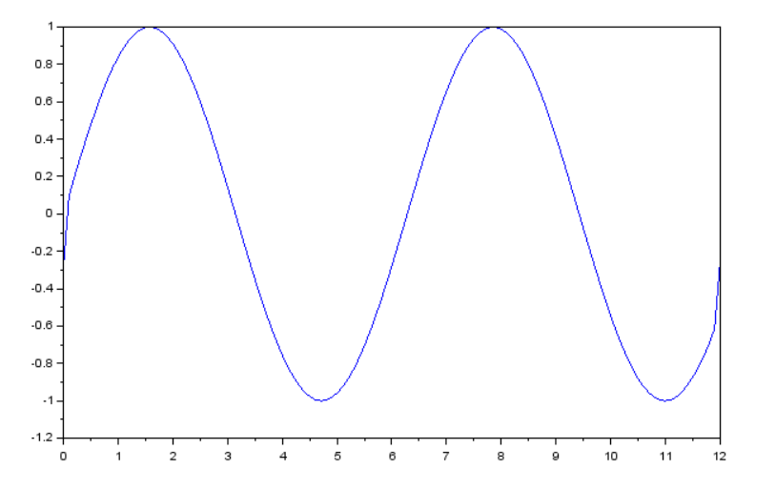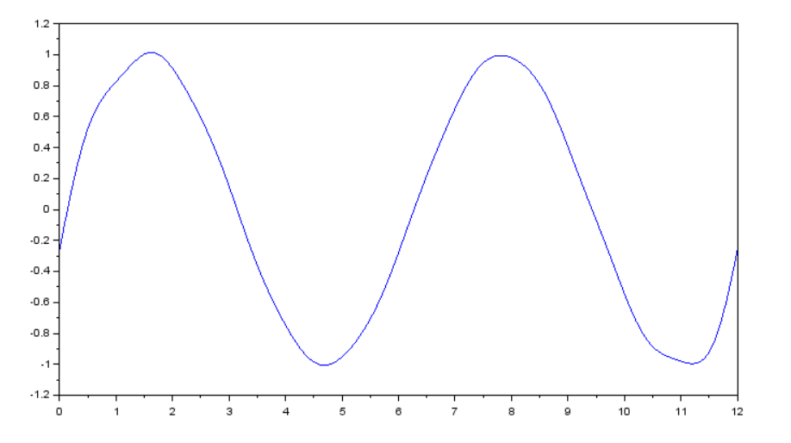>> fourierplot(f,10,6); >> fourierplot(f,500,6);

>>deff('a=f(x)','a=x^2');

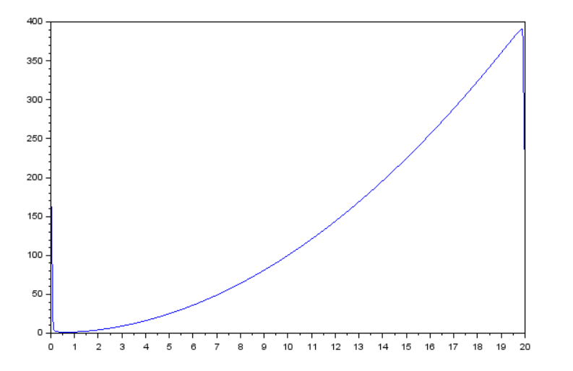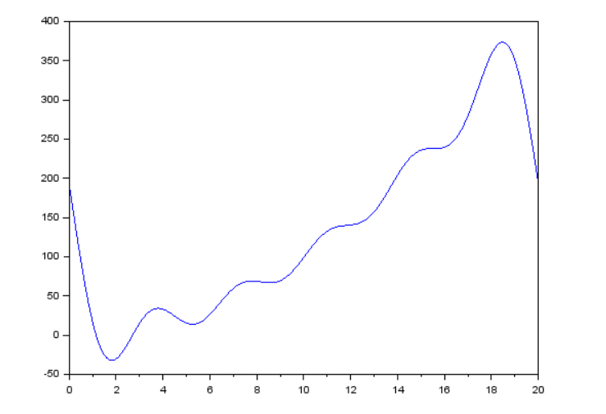>>fourierplot(f,5,10); >>fourierplot(f,800,10);

>>deff('a=f(x)','a=e^-x');

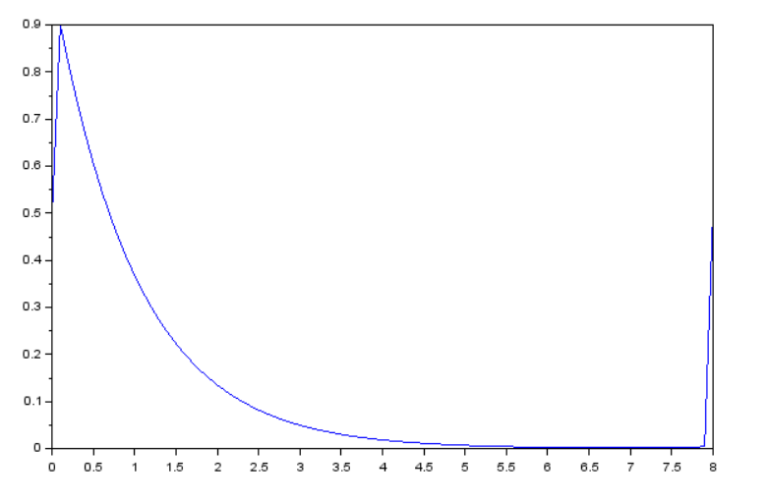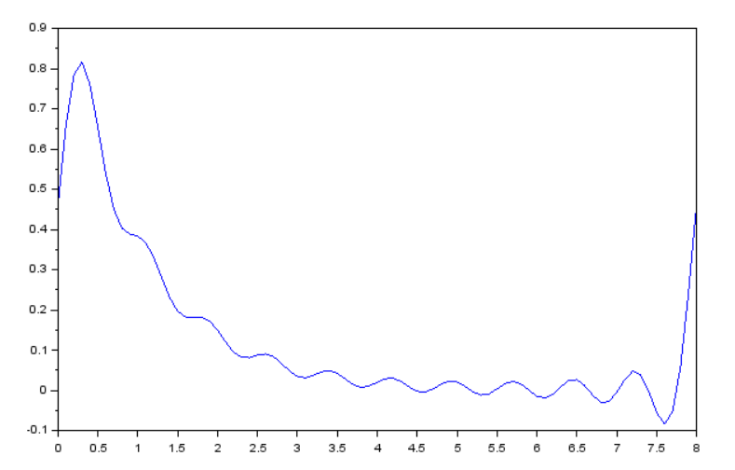>>fourierplot(f,10,4); >>fourierplot(f,800,4);

**Conclusion :** As value of n increases, reconstruction of the function is more accurate and reconstructed signal is more similar to actual function.